Network Status Report

|  |  |  |  |  |  |  |
| --- | --- | --- | --- | --- | --- | --- |
| **Member Name** | **Date Time** | **Firewall Machine** | **Web Server** | **Log / Snort** | **Windows XP (Opt.)** | **Conclusion** |
| David Tran | Oct 30  20:16:42 - 20:16:51 |  |  | Snort has detected 3 RDP attempts from China; IP Address: 218.77.79.43 | IP address of Windows XP: 192.168.25.3 | Attempted three password cracks before removed from RDP access. |
| David Tran | Oct 30  18:10:14 - 22:15:50 | Multiple SSH attempts from multiple IPs; sources mainly from China |  |  |  |  |
| David Tran | Oct 31 (All Day) | Multiple SSH attempts from multiple IPs; sources mainly from China; changed user from “root” to “admin” |  |  |  |  |
| David Tran | Oct 31 |  |  | Attempted Denial of Service to Windows WS; from the States; attempting to gain entry through RDP |  |  |
| David Tran | Oct 31  14:55:33 - 14:59:10 |  |  | WEB-CGI attacks on Web Site from 188.226.143.68; origin from Russia |  |  |
| David Tran | Oct 31  17:27:02 - 17:32:20 |  |  | RDP Brute Force from 108.178.57.126 |  |  |
| David Tran | Oct 31  20:59:45 - 21:08:00 |  |  | RDP brute force from 58.64.134.24 |  |  |
| David Tran | Oct 31 22:04:34 - 22:09:20 |  |  | RDP Brute Force from 23.80.91.194 |  |  |
| David Tran | Oct 31 |  |  |  |  | Files of Interest: chronyd.log and dhclient.log |
| David Tran | Nov 1 | SSH attempts failed; Port Scans |  |  |  | Files of Interest: chronyd.log and dhclient.log |
| Peter Haile | Oct 31  14:55:30 -  14:59:14 | Suspected network crash due to shellshock attacks | Checking bash history: does not show anything unusual  Checking httpd access.log reveals multiple shellshock attempts from 188.226.143.68 as shown in figure A.1 | Snort alerts reveal attempts on remote CGI script execution. |  | The firewall’s public network card ‘em1’ released its IP address causing the network to go down. We cannot deduce that the network went down due to this attack.  However, we believe the attacker was using a script to scan our server for possible shellshock vulnerabilities.  -Script  -Multiple attempts using different .cgi files  -Each attempt are seconds apart  -Command to execute simply visits a website (potentially recording access for future attacks)  If this was a scan, the attacker will know we are vulnerable since he hit our cgi file ‘test.cgi’ in his scan as shown in figure A.2 |
| Peter Haile | November 3 | Suspected shellshock attack on webserver | Checking bash history: does not show anything unusual  Checking httpd access.log reveals attempted shellshock attacks from 83.143.128.67 as shown in figuare B.1 | Snort alerts reveal attempts on remote CGI script execution. |  |  |
| David Tran | Nov 3 | SSH attempts failed; Port Scans |  | Snort broken due to corrupt DAQ |  | Files of Interest: chronyd.log and dhclient.log |
| David Tran | Nov 4 | SSH attempts failed; Port Scans |  | Snort broken due to corrupt DAQ |  | Files of Interest: chronyd.log and dhclient.log |
| David Tran | Nov 5 | SSH attempts failed; Port Scans |  | Snort broken due to corrupt DAQ |  | Files of Interest: chronyd.log and dhclient.log |
| David Tran | Nov 6 | SSH attempts failed; Port Scans |  | Snort and DAQ files fixed |  | Files of Interest: chronyd.log and dhclient.log |
| David Tran | Nov 7 | SSH attempts failed; Port Scans |  | Snort and DAQ files fixed |  | Files of Interest: chronyd.log and dhclient.log |
| David Tran | Nov 7  10:33:56 -  10:48:50 |  |  | RDP Brute Force from 180.153.146.103 |  |  |
| David Tran | Nov 7 13:36:17,  15:21:26 |  |  | A couple of attempts from 86.98.83.45; source from Dubai |  |  |
| David Tran | Nov 7  19:58:36 -  20:12:12 |  |  | RDP Brute Force from 220.160.201.164 |  |  |
| David Tran | Nov 7  21:22:21 -  21:34:01 |  |  | RDP Brute Force from 116.21.64.191 |  |  |
| David Tran | Nov 8 |  |  |  |  | Same activities as Nov 7 from different sources; Files of Interest: chronyd.log and dhclient.log |
| David Tran | Nov 9 |  |  |  |  | Same activities as Nov 7 from different sources; Files of Interest: chronyd.log, snort.log, and dhclient.log |
| David Tran | Nov 10 |  |  |  |  | Same activities as Nov 7 from different sources; Files of Interest: chronyd.log, snort.log, and dhclient.log |
| David Tran | Nov 11 |  |  |  |  | Same activities as Nov 7 from different sources; Files of Interest: chronyd.log, snort.log, and dhclient.log |
| David Tran | Nov 12 |  |  |  | Snort.log abnormally short for this day... | Same activities as Nov 7 from different sources; Files of Interest: chronyd.log, snort.log, and dhclient.log |
| David Tran | Nov 13 |  |  |  |  | Same activities as Nov 7 from different sources; Files of Interest: chronyd.log, snort.log, and dhclient.log |
| David Tran | Nov 14 |  |  |  |  | Same activities as Nov 7 from different sources; Files of Interest: chronyd.log, snort.log, and dhclient.log |
| David Tran | Nov 15 |  |  |  |  | Same activities as Nov 7 from different sources; Files of Interest: chronyd.log, snort.log, and dhclient.log |
| David Tran | Nov 16 |  |  |  |  | Same activities as Nov 7 from different sources; Files of Interest: chronyd.log, snort.log, and dhclient.log |
| David Tran | Nov 17 |  |  |  |  | Same activities as Nov 7 from different sources; Files of Interest: chronyd.log, snort.log, and dhclient.log |
| David Tran | Nov 18 |  |  |  |  | Same activities as Nov 7 from different sources; Files of Interest: chronyd.log, snort.log, and dhclient.log |
| David Tran | Nov 19 |  |  |  |  | Same activities as Nov 7 from different sources; Files of Interest: chronyd.log, snort.log, and dhclient.log |
| David Tran | Nov 20 |  |  |  |  | Same activities as Nov 7 from different sources; Files of Interest: chronyd.log, snort.log, and dhclient.log |
| David Tran | Nov 21 |  |  |  |  | Same activities as Nov 7 from different sources; Files of Interest: chronyd.log, snort.log, and dhclient.log |
| David Tran | Nov 22 |  |  |  |  | Same activities as Nov 7 from different sources; Files of Interest: chronyd.log, snort.log, and dhclient.log |
| David Tran | Nov 23 |  |  |  |  | Same activities as Nov 7 from different sources; Files of Interest: chronyd.log, snort.log, and dhclient.log |
| David Tran | Nov 24 |  |  |  |  | Same activities as Nov 7 from different sources; Files of Interest: chronyd.log, snort.log, and dhclient.log |

A.1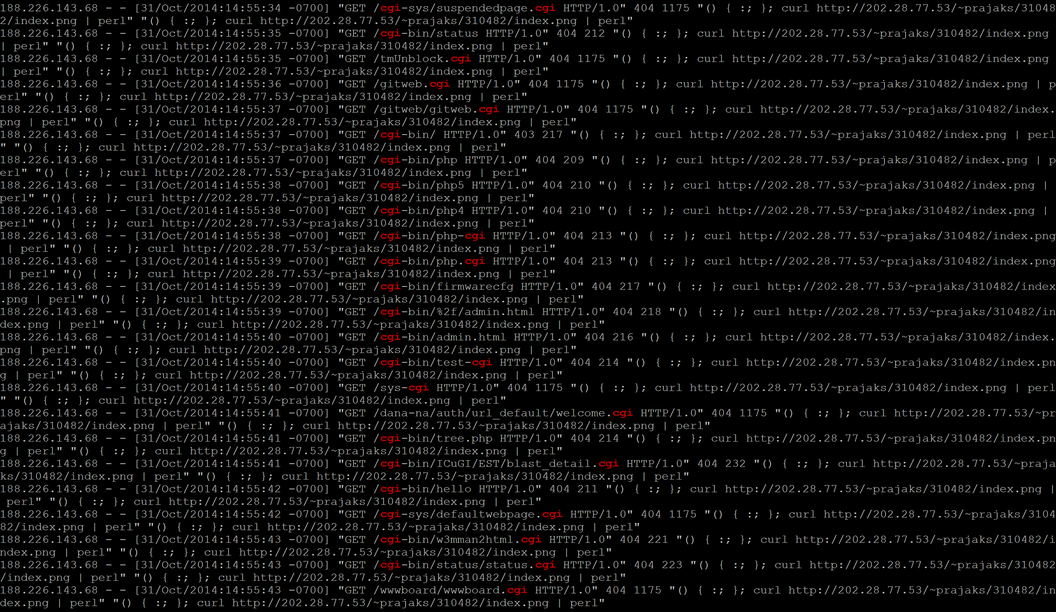

A.2



B.1

